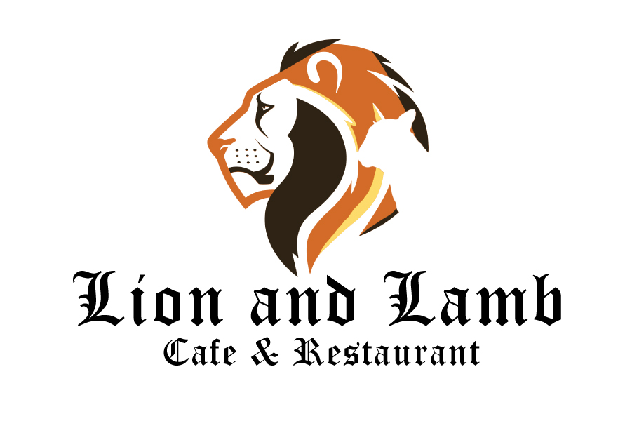

Keeping customers and staff safe during COVID 19

- Prior to reopening our premises have been thoroughly deep cleaned and ventilated.

- We have implemented a new table layout for inside and outside seating area to allow for social distancing.

- We will be limiting the number of customers to 30 in the premises at any time. We recommend that you ring us to make a booking.

- Hand sanitising station has been installed in the Lion and Lamb Cafe.

- Increased sanitising and disinfection of all surfaces will be in place, this includes menus, tables, chairs, door handles, etc.

- Our staff have been re-trained to provide safe experience to our customers, this includes increased frequency of hand washing, sanitising all surfaces and how to serve customers

- We ask that you remain mindful of social distancing specially when entering or exiting our premises and when using the toilet.

- We will be providing table service only, please refrain from coming up to the counter as you will be politely asked to return to your table.

- Our preferred method of payment is contactless to keep everyone safe.

- All of our staff is subject to daily wellness checks, anyone with symptoms will not be allowed to work.

- We respectfully ask that you do not visit us if you are showing any COVID 19 symptoms

- We comply with COVID 19 risk assessment in line with the government guidance, which will be reviewed regularly.

